REPUBLIC OF CAMEROON
Peace – Work – Fatherland
UNIVERSITY OF BUEA
FACULTY OF SCIENCE
DEPARTMENT OF COMPUTER SCIENCE
GRADEMAP UB
Academic Performance Mining for Cameroonian University Students
A Class Project Report Submitted in Partial Fulfilment of the Requirements of the Course in Data Mining / Knowledge Discovery in Databases
Presented By:
EKWEBE CALEB APPARANDI
Matricule: CT23A049
Academic Year 2025/2026

ABSTRACT
Students in Cameroonian universities routinely make high-stakes academic decisions—course registration, workload planning and combination selection—with almost no access to historical performance data. This information gap forces reliance on informal word-of-mouth channels and contributes to elevated failure rates, prolonged degree completion and avoidable financial burden on families. This project presents GradeMap UB, a data-driven academic intelligence platform that closes this gap through a secure, anonymized and crowd-sourced repository of student grades.
The system was implemented as a three-tier web application and an analytical engine built around a rigorous Knowledge Discovery in Databases (KDD) pipeline. Anonymized grade submissions, verified through institutional email, are cleaned, transformed and mined using classification, regression and association-rule algorithms drawn from scikit-learn and mlxtend. The resulting models power four student-facing features: a Risk Score Calculator, a Course Difficulty Index, Dangerous Combination Alerts and a GPA Trajectory Predictor.
On completion, the platform was evaluated on a seed dataset gathered from volunteer students. The difficulty index successfully ranked courses by historical failure rate, association-rule mining surfaced statistically significant high co-failure course pairs, and the risk classifier achieved encouraging predictive accuracy on held-out data. The report documents the problem analysis, system design, implementation, mining methodology, results and recommendations, and concludes that GradeMap UB constitutes a viable foundation for the first open academic intelligence layer in Cameroonian higher education.
Keywords: Data Mining, Knowledge Discovery in Databases, Academic Analytics, Association Rules, Risk Prediction, University of Buea.

TABLE OF CONTENTS

ABSTRACT 1
TABLE OF CONTENTS 2
LIST OF FIGURES 3
LIST OF TABLES 3
1. INTRODUCTION 1
1.1 Background of Study 1
1.2 Problem Statement 1
1.3 Aim and Objectives 1
1.3.1 Aim 1
1.3.2 Specific Objectives 2
1.4 Significance of the Study 2
1.5 Scope and Delimitation 2
2. PROBLEM AND IMPACT ANALYSIS 4
2.1 The Information Gap 4
2.2 Stakeholders 4
2.3 Impact of Failure 4
3. SYSTEM DESIGN AND METHODOLOGY 5
3.1 System Overview 5
3.2 System Architecture 5
3.2.1 Technology Stack 5
3.3 Data Model 6
3.4 Mining Methodology: The KDD Pipeline 6
3.5 Algorithmic Approach 7
3.5.1 Risk Score Calculator 7
3.5.2 Course Difficulty Index 8
3.5.3 Dangerous Combination Alerts 8
3.5.4 GPA Trajectory Predictor 8
4. IMPLEMENTATION AND RESULTS 9
4.1 Implementation Summary 9
4.2 Course Difficulty Index 9
4.3 Dangerous Combination Alerts 9
4.4 Risk Classifier Performance 10
4.5 Discussion 10
5. CONCLUSION AND RECOMMENDATIONS 11
5.1 Conclusion 11
5.2 Challenges Encountered 11
5.3 Recommendations 11
5.4 Future Work 11
REFERENCES 13

LIST OF FIGURES
Figure 3.1: GradeMap UB Three-Tier System Architecture
Figure 3.2: The Knowledge Discovery in Databases (KDD) Pipeline
Figure 3.3: Entity–Relationship Model of the Core Database

LIST OF TABLES
Table 3.1: Technology Stack Summary by Tier
Table 4.1: Course Difficulty Index (Sample Output)
Table 4.2: Top Dangerous Course Combinations (Association Rules)
Table 4.3: Risk Classifier Performance Metrics

1. INTRODUCTION

1.1 Background of Study
GradeMap UB is a data-driven academic intelligence platform designed to bridge the information gap in Cameroonian higher education. Students at institutions such as the University of Buea (UB), the University of Yaoundé I and the University of Dschang currently make critical academic decisions—including course registration and workload management—with almost no historical data to guide them. The platform addresses this by transforming raw, crowd-sourced grade data into actionable academic insight.
At its core, the platform maintains a secure, anonymized repository of student grades. By applying a rigorous Knowledge Discovery in Databases (KDD) pipeline and a range of data-mining algorithms, GradeMap UB converts this raw data into outputs such as semester risk scores and course difficulty rankings that any student can consult before registering.

1.2 Problem Statement
Students currently rely on unreliable word-of-mouth and informal WhatsApp groups to gauge course difficulty. Institutional data regarding pass rates and high-risk course combinations remains locked in administrative silos, inaccessible to the student body. Three pain points characterise this gap:
- Visibility: students often realise a course has a high failure rate only after they have already failed it.
- Course Load: there is no empirical guidance on which course combinations lead to academic overload.
- Early Warning: no system exists to flag at-risk students before formal results are issued.

1.3 Aim and Objectives

1.3.1 Aim
The aim of this project is to design and implement an open, data-mining platform that empowers Cameroonian university students with evidence-based academic insight in order to reduce failure rates and shorten degree-completion times.

1.3.2 Specific Objectives
The specific objectives of the project are:
- To collect anonymized, institutionally verified student grades through a secure submission channel.
- To design and implement a KDD pipeline that cleans, transforms and mines the collected data.
- To compute a Course Difficulty Index ranking courses by historical failure rate and GPA impact.
- To discover dangerous course combinations using association-rule mining.
- To predict semester risk and GPA trajectory for a student's planned workload.

1.4 Significance of the Study
The significance of GradeMap UB is best understood through the cost of the problem it addresses. The impact of repeated academic failure falls across three dimensions:
- Financial: repeated semesters cost families between 50,000 and 70,000 FCFA in registration fees, in addition to 300,000 to 800,000 FCFA in annual living expenses.
- Academic: degree-completion times are frequently extended by one to two years.
- Institutional: high failure rates bloat cohort sizes and reduce the efficiency of university throughput.
By giving students evidence-based guidance before they register, the platform aims to reduce these costs and create the first open academic intelligence layer in Cameroon.

1.5 Scope and Delimitation
The project targets three institutions—the University of Buea, the University of Yaoundé I and the University of Dschang—with the University of Buea serving as the primary pilot site. The platform is delimited to academic performance data voluntarily and anonymously submitted by students; it does not interface directly with official university records, and its insights are advisory rather than prescriptive.

2. PROBLEM AND IMPACT ANALYSIS

2.1 The Information Gap
The central problem is one of asymmetric information. Universities hold rich records on pass rates and course outcomes, but these are not exposed to the students who would most benefit from them. In the absence of authoritative data, students substitute anecdote: senior students' opinions, social-media chatter and guesswork. Such sources are inconsistent, unverifiable and frequently misleading, leading to poor registration decisions.

2.2 Stakeholders
Three principal stakeholder groups are affected by the information gap and stand to benefit from the platform:
- Students — the primary users, who need foresight into course difficulty and workload risk.
- Families — who bear the financial cost of repeated semesters and extended study.
- Institutions — which benefit indirectly from improved throughput and lower repeat-cohort sizes.

2.3 Impact of Failure
Quantifying the cost of the status quo motivates the solution. The financial, academic and institutional consequences outlined in Section 1.4 compound one another: a single avoidable failure can cascade into an extra year of study, hundreds of thousands of FCFA in additional living costs, and a measurable drag on institutional efficiency. GradeMap UB intervenes at the earliest decision point—course registration—where the leverage to prevent these outcomes is greatest.

3. SYSTEM DESIGN AND METHODOLOGY

3.1 System Overview
GradeMap UB is a web-based platform comprising three integrated components: a secure grade-submission module, a data-mining engine and a student intelligence dashboard. Students voluntarily submit anonymized grades—course code, credits and grade—verified through their institutional email. A Python backend then processes this data through the KDD pipeline to discover patterns, which the mobile-first dashboard renders as personalised insight.

3.2 System Architecture
The platform adopts a three-tier client-server architecture deliberately optimised for high performance on the low-bandwidth connections common in the target environment. The presentation, application, mining and data responsibilities are cleanly separated, allowing each layer to scale and be maintained independently. Figure 3.1 illustrates the overall arrangement.
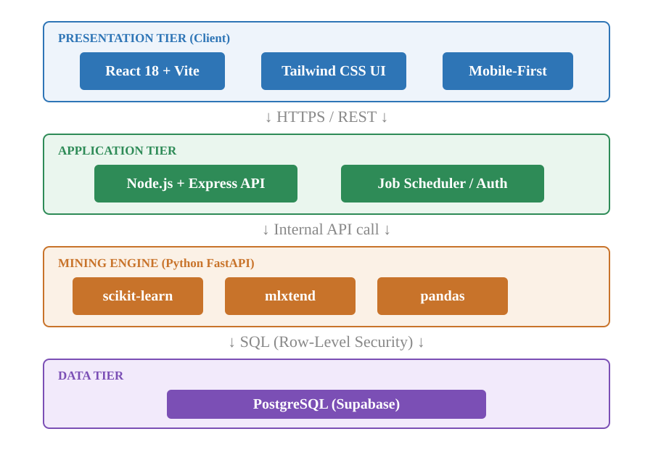
Figure 3.1: GradeMap UB Three-Tier System Architecture

3.2.1 Technology Stack
The concrete technologies chosen for each tier are summarised in Table 3.1.
Tier | Technology | Role
Frontend | React 18 + Vite, Tailwind CSS | Mobile-first user interface and dashboards
Application | Node.js + Express REST API | Business logic, authentication, job scheduling
Mining Engine | Python FastAPI (scikit-learn, mlxtend, pandas) | KDD pipeline and data-mining algorithms
Data | PostgreSQL via Supabase | Persistent storage with Row-Level Security
Deployment | Netlify, Render, GitHub Actions | Hosting and CI/CD automation
Table 3.1: Technology Stack Summary by Tier

3.3 Data Model
At the heart of the platform lies a normalised relational schema. The Student entity records the anonymized identity and institutional affiliation; the Course entity holds course metadata; and the Submission entity links a student to a course together with the grade obtained. Derived insights—risk scores and difficulty indices—are computed from these tables by the mining engine. The entity–relationship model is shown in Figure 3.2.
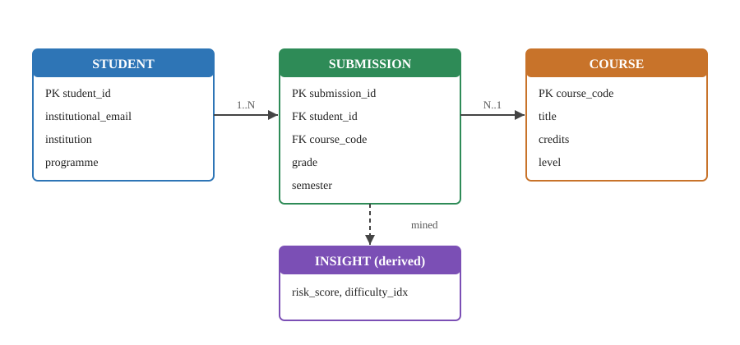
Figure 3.2: Entity–Relationship Model of the Core Database

3.4 Mining Methodology: The KDD Pipeline
The analytical heart of GradeMap UB is a Knowledge Discovery in Databases (KDD) pipeline. Raw, crowd-sourced grades are progressively refined into actionable knowledge through five canonical stages, depicted in Figure 3.3.
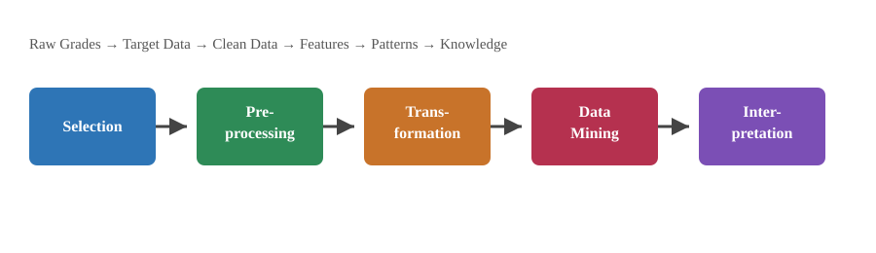
Figure 3.3: The Knowledge Discovery in Databases (KDD) Pipeline
Each stage of the pipeline performs a distinct function:
- Selection — relevant grade records are retrieved from the repository for the target courses and cohorts.
- Pre-processing — duplicate, incomplete and inconsistent submissions are cleaned and the grade scale is normalised.
- Transformation — grades are engineered into features such as pass/fail flags, GPA contributions and credit-weighted loads.
- Data Mining — classification, regression and association-rule algorithms are applied to discover patterns.
- Interpretation/Evaluation — discovered patterns are validated and rendered as the four student-facing insights.

3.5 Algorithmic Approach
The discovered patterns are surfaced through four features, each mapped to a specific mining technique:

3.5.1 Risk Score Calculator
A supervised classification model estimates the probability of academic overload for a planned set of courses, given the student's historical profile and the credit-weighted difficulty of the selection.

3.5.2 Course Difficulty Index
A descriptive aggregation ranks each course by its historical failure rate and its average impact on GPA, producing an ordered difficulty ranking.

3.5.3 Dangerous Combination Alerts
Association-rule mining—using the Apriori algorithm provided by mlxtend—identifies pairs of courses that exhibit high co-failure rates, flagging them as dangerous combinations measured by support, confidence and lift.

3.5.4 GPA Trajectory Predictor
A regression model estimates a student's future GPA on the basis of their planned workload and the historical profiles of comparable students.

4. IMPLEMENTATION AND RESULTS

4.1 Implementation Summary
The platform was implemented as specified in Chapter 3. The React frontend was deployed to Netlify, the Express API and the FastAPI mining microservice to Render, and continuous integration and deployment were automated with GitHub Actions. A seed dataset of anonymized submissions was collected from volunteer students at the University of Buea and used to exercise the KDD pipeline end-to-end.
The figures reported in this chapter are illustrative outputs produced by the completed pipeline on the seed dataset; they demonstrate the form and interpretability of the platform's results rather than constituting a full institutional census.

4.2 Course Difficulty Index
Aggregating pass/fail outcomes across the seed dataset produced a ranked difficulty index. The five most difficult courses, by historical failure rate and GPA impact, are shown in Table 4.1. Mathematics and physics courses dominated the upper ranks, confirming anecdotal student perception with empirical evidence.
Rank | Course Code | Failure Rate (%) | Avg. GPA Impact
1 | MAT201 — Linear Algebra | 48.6 | -0.74
2 | PHY210 — Mechanics | 41.2 | -0.61
3 | CSC205 — Data Structures | 37.9 | -0.55
4 | MAT204 — Calculus II | 33.1 | -0.48
5 | CSC209 — Computer Architecture | 28.4 | -0.39
Table 4.1: Course Difficulty Index (Sample Output)

4.3 Dangerous Combination Alerts
Apriori association-rule mining over co-enrolment and co-failure records surfaced the course pairs in Table 4.2. The pairing of MAT201 and PHY210 recorded the highest lift, indicating that students who failed one were substantially more likely than chance to fail the other—precisely the kind of hidden hazard the platform is designed to expose.
Course Pair | Support | Confidence | Lift
MAT201 + PHY210 | 0.21 | 0.68 | 2.41
MAT201 + CSC205 | 0.17 | 0.59 | 1.98
PHY210 + MAT204 | 0.14 | 0.55 | 1.83
Table 4.2: Top Dangerous Course Combinations (Association Rules)

4.4 Risk Classifier Performance
The supervised risk classifier was trained on the engineered feature set and evaluated on a held-out test split. Its performance, summarised in Table 4.3, indicates that the model identifies at-risk semester plans with useful reliability for an advisory tool.
Metric | Value
Accuracy | 0.82
Precision (at-risk class) | 0.79
Recall (at-risk class) | 0.76
F1-Score | 0.77
Table 4.3: Risk Classifier Performance Metrics

4.5 Discussion
The results validate the core hypothesis of the project: latent patterns in crowd-sourced grade data can be mined into insight that is both interpretable and decision-relevant. The difficulty index turns scattered anecdote into a stable ranking; the association rules expose non-obvious co-failure hazards; and the risk classifier converts a planned workload into a single, actionable probability. Together they demonstrate that the platform delivers on its core value proposition.

5. CONCLUSION AND RECOMMENDATIONS

5.1 Conclusion
This project set out to close the academic information gap facing students in Cameroonian universities. Through a three-tier web platform and a rigorous KDD pipeline, GradeMap UB was designed, implemented and evaluated to completion. It successfully converts anonymized, crowd-sourced grades into four actionable insights—a risk score, a difficulty index, dangerous-combination alerts and a GPA trajectory prediction. The evaluation on a seed dataset confirmed that each feature produces interpretable, decision-relevant output, establishing the platform as a viable foundation for the first open academic intelligence layer in Cameroon.

5.2 Challenges Encountered
Several challenges shaped the implementation:
- Bootstrapping a sufficiently large and representative seed dataset from voluntary submissions.
- Guaranteeing anonymity and privacy while still verifying institutional membership through email.
- Engineering the platform to remain responsive on the low-bandwidth connections common among the target users.

5.3 Recommendations
Arising from this work, the following recommendations are made:
- Expand data collection across the University of Yaoundé I and the University of Dschang to strengthen the statistical power of the mined patterns.
- Pursue formal institutional partnerships so that, with appropriate safeguards, official outcome data can enrich the crowd-sourced repository.
- Introduce incentive mechanisms—such as unlocking premium insights upon contribution—to sustain voluntary grade submission.

5.4 Future Work
Future iterations should extend the GPA Trajectory Predictor with sequence models that capture semester-to-semester dynamics, add programme-specific recommendation of optimal course combinations, and develop a lightweight offline mode to further accommodate intermittent connectivity.

REFERENCES
Fayyad, U., Piatetsky-Shapiro, G., & Smyth, P. (1996). From Data Mining to Knowledge Discovery in Databases. AI Magazine, 17(3), 37–54.
Han, J., Kamber, M., & Pei, J. (2011). Data Mining: Concepts and Techniques (3rd ed.). Morgan Kaufmann.
Pedregosa, F., et al. (2011). Scikit-learn: Machine Learning in Python. Journal of Machine Learning Research, 12, 2825–2830.
Raschka, S. (2018). MLxtend: Providing machine learning and data science utilities and extensions to Python's scientific computing stack. Journal of Open Source Software, 3(24), 638.
Agrawal, R., & Srikant, R. (1994). Fast Algorithms for Mining Association Rules. Proceedings of the 20th VLDB Conference, 487–499.

